CHAPTER ONE
BACKGROUND KNOWLEDGE OF SIWES
  - About SIWES
The Students’ Industrial Work Experience Scheme (SIWES) is a skill training program designed to expose and prepare students of universities, polytechnics and Colleges of Education for the industrial work situation they are likely to meet after graduation. The scheme also affords students the opportunity of familiarizing and exposing themselves to the needed experience in handling equipment and machinery that are usually not available in their institutions (Student industrial work experienced scheme handbook, 2015/2016).
Before establishment of the scheme, there was a growing concern among our industrialists that graduates of institutions of higher learning lacked adequate practical background studies preparatory for employment industries. Thus the employers were of the opinion that the theoretical education going on in higher institutions was not responsive to the needs of the employers of labor. It is against this background that the rationale for initiating and designing the scheme by the fund during its formative years – 1973/74 was introduced to acquaint students with the skills of handling employers’ equipment and machinery. The ITF solely funded the scheme during its formative years. But as the financial involvement became unbearable to the fund, it withdrew from the scheme in 1978. The federal government handed over the scheme in 1979 to both the National Universities Commission (NUC) and the National Board for Technical Education (NBTE). Later, the federal government in November 1984 reverted the management and implementation of the scheme to ITF and it was effectively taken over by the Industrial Training Fund (ITF) in July 1985 with the funding being solely borne by the federal government (Student industrial work experienced scheme handbook, 2015/2016).
  - Scope of SIWES
(Student industrial work experienced scheme handbook, 2015/2016) This is based on the number of weeks or months that student is expected to stay for its attachment. The minimum duration for SIWES should normally be six (6) months, twenty-four weeks (24) weeks for University Engineers and Technologist. The cumulative total duration of attachment over the entire period of the course should preferably be not shorter than 240hrs full time which will take place during term-time or long vocation. Induction sessions which is conducted by teaching departments to install the concepts of key skills (skills for learning, employment and life), work place safety and professional expectations, legalities and ethics.

  - Aim and Objectives of SIWES
Aims and Objective of SIWES is to:
- Provide avenue for students in the institution of higher learning to acquire industrial skills and experience in their approved course of study.
- Prepare students for the industrial works situation which are likely to meet after graduation.
- Expose students to work techniques in handling equipment and machinery that are mostly not available in their various institution.
- Provide students with an opportunity to apply knowledge in real work situation thereby bridging the gap between theories and practices.
- Enlist and strengthens employers’ involvement in the entire educational process and prepare students for employment in industry and commerce.
- Moreover, it helps them to gain interpersonal and entrepreneurial skills and also instill in them the right kind of work attitudes and professionalism through interactions with peoples in the organizations and observations of their future role in the tertiary.

  - Benefits of SIWES
(Campbell, 2017) Expert identified industrial experience as necessity for proper job preparation. This is because productivity is enhanced by experienced graduate or new entrance into the world of work really needs and exposure to the value and skills of the industry. Therefore, without appropriate skills and experiences young graduates are not properly trained on work, norms and role behavior among others, these components will ensure success at the job place. Today Information and Communication Technology (ICT) is changing the way many jobs are performed, thus altering the knowledge and skills required of workers. Consequently, a new level of competency is required of our students. This cannot be sufficiently met by training facilities in our education institutions hence, the need for collaborative effort between institutions and industrial sector. The major benefits accruing to students who participate conscientiously in industrial training are the skills and competencies they acquire. These relevant production skills (RPSs) remain a part of the recipients of industrial training as lifelong assets which cannot be taken away from them. This is because the knowledge and skills acquired through training are internalized and become relevant when required to perform jobs or functions. Provision of an enabling environment when students can develop and enhance personal attributes such as critical thinking, creativity, initiatives, resourcefulness, leadership, time management, presentation skills and interpersonal skills, amongst others (Campbell, 2017).

CHAPTER TWO
INDUSTRIAL WORK EXPERIENCE AT GOODISOFT TECHNOLOGIES
2.1 History and Background Knowledge of Goodisoft Technologies
Goodisoft Technologies is located at 3 Gunning Road Abakaliki, Ebonyi state. The company is a private non-governmental organization established in the year 2022. The company is registered under Corporate Affairs Commission (CAC). It is owned and managed by Mr. Goodnews Essien. It is an institute basically for development of computer software’s and computer training.
2.2 Organizational Objectives and Scope of Services
- Goodisoft Technologies have a vision of providing easy to use software based solutions which are capable of effectively meeting user’s needs.
- Speed: We hold speed at optimum priority both in the delivery of our solutions and in the experience of our customers.
- Tenacity: The Goodisoft technologies team is dedicated to stay on course in the ongoing adventure to provide creative software based solutions efficient enough to solve customers’ challenges and give them satisfaction.
- Leading Edge Technology: They aim at being at the fore front of the global wave of technological advancement in the nearest future; as result we settle for nothing less than the use of latest tools and technology in the development of our solutions.
- Integrity: The Goodisoft technologies team is made up of dedicated individuals and associate how hold as a wash word. We are built to last.

Goodisoft Technologies company specializes in:
- Web development
- Android applications
- Artificial Intelligent
- Blockchain programming
- Data Analysis
- Graphics design
- Computer programming
- Computer training
- Project research and writing
2.3 Organogram of Goodisoft Technologies
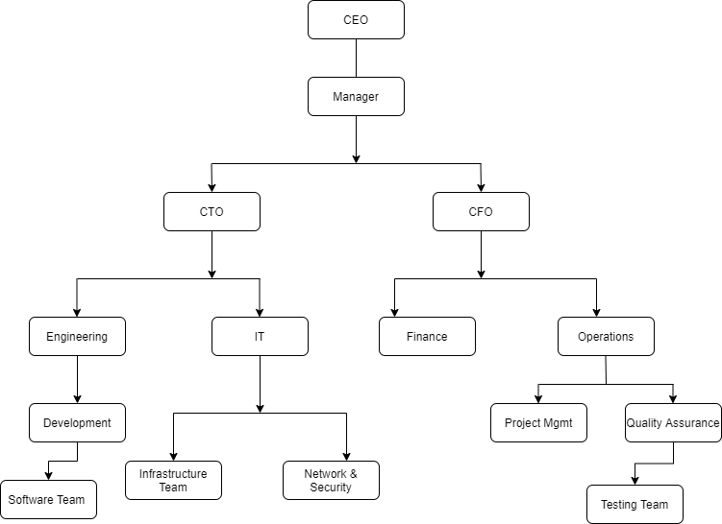
Fig 2.1 Organogram of Goodisoft Technologies
2.4 Experience Gained during the Industrial Training
During the initial twenty weeks of my industrial training, I was immersed in a comprehensive web design course within the department where I was stationed. This immersive experience exposed me to the intricate world of website creation, guiding me through each step of the process. Throughout the training, I delved into fundamental web development languages, such as HTML, which forms the backbone of web content, and CSS, a styling language essential for enhancing the visual appeal of websites.
Additionally, I gained proficiency in Bootstrap, a front-end framework that facilitates the development of responsive and aesthetically pleasing user interfaces. The training also equipped me with essential skills in JavaScript, enabling me to add dynamic and interactive elements to websites. The practical approach adopted during the course allowed me to apply theoretical knowledge to real-world scenarios, honing my ability to create functional and visually appealing websites.
By the end of this training period, I developed a solid foundation in web design, acquiring a versatile skill set that includes understanding the structure and layout of web pages, implementing responsive design principles, and incorporating dynamic functionalities. This hands-on experience not only enriched my technical capabilities but also instilled a deep appreciation for the intricacies involved in crafting an engaging online presence. Overall, these twenty weeks proved to be a valuable and enriching journey into the realm of web development.

CHAPTER THREE
SKILLS ACQUIRED AND PROBLEMS ENCOUNTERED
3.1 Technical Skills Acquired
During my industry training at Goodisoft technologies, I acquired the following skills:
- Frontend Web Development (Html, Css, Bootstrap, JavaScript)
- Project Writing
3.1.1 Frontend Web Development
Frontend web development refers to the part of web development that involves creating and designing the user-facing parts of a website or web application. This includes everything that users see and interact with, such as the layout, navigation, content, and visual elements.
To create the frontend of a website, web developers use a variety of programming languages, including HTML, CSS, Bootstrap and JavaScript. HTML provides the structure and content of the page, CSS is used for styling and layout, and JavaScript is used for interactive elements such as dropdown menus, forms, and animations.
Frontend developers also use a variety of frameworks and libraries to speed up the development process and ensure compatibility across different browsers and devices.
Therefore, frontend web development is a crucial aspect of building a successful website or web application, as it determines how users interact with the product and how visually appealing and intuitive it is to use (web-development, n.d.).

3.1.1.1 HTML 5 (Creating a web page)
A Web page is a document, identified by an URL that can be retrieved on the Web. Typically, a Web page is written in HTML, the Hypertext Mark-up Language. When a Web browser receives an HTML document, it can format and render the content for viewing, listening, or printing. The user can also follow embedded hyperlinks, or simply links, to visit other Web pages. HTML enables you to structure and organize text, graphics, pictures, sound, video, and other media content for processing and display by browsers. HTML supports headings, paragraphs, lists, tables, links, images, forms, frames, and so on. The major part of a website is usually a set of HTML documents. Learning and understanding HTML is fundamental to Web Design and Programming.
To create HTML files, you may use any standard text editor such as Notepad or Visual Studio Code (preferred).
HTML is a mark-up language that provides tags for you to organize information for the Web. By inserting HTML tags into a page of text and other content, you mark which part of the page is what to provide structure to the document.
A Simple HTML Page Structure
<! Doctype Html> Used to inform the browser that this is a html document
<html> (Top level element)
<head> (Top level element)
<title> Welcome to Goodisoft</title>
</head>
<body> (Top level element)
<h1> Goodisoft Technologies </h1> (Block level element)
<p> Goodisoft has graduated over 50 students </p> (Block level element)
</body>
</html>
Form
The form element of HTML is designed to collect input from Web surfers for processing on the server side. You place different types of input control elements inside a form to receive user input for server-side processing. The form element may contain any kind of block elements so you can include instructions, explanations, and illustrations together with input controls.
HTML Code for a simple form
<form>
<fieldset>
<legend> Contact Us</legend>
<div class="cent"
<fieldset id="live">
<div class="background">
<div class="username"> Name: <div class="namebox"> <input type="text"/></div> </div>
</br><div class="password">Password: <input type="password"/> </div>
</br> <div class="state">State of origin:<input list="states"/> </div>
<datalist id="states">
<option value="Abuja">
<option value="Lagos">
<option value="Ekiti">
</datalist>
</br> <div class="message"> Message Us </div ><textarea rows="10" cols="50"> </textarea>
</br><button type="button"> Submit </button>
<div class="resetbutton"><button type="reset" value="reset" name="resetbutton"> Reset</button></div>
</div>
</div>
</fieldset>
</form>
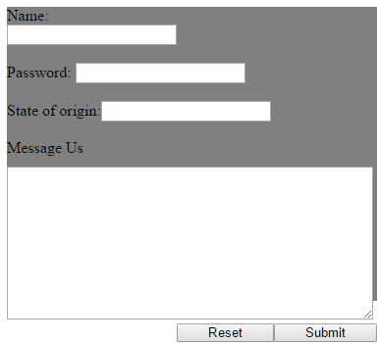

Fig 3.1 A Simple Form

3.1.1.2 CSS IN DETAILS
The term CSS stands for Cascading Style Sheet used for formatting html document. It is a style sheet language used for describing the presentation of a document written in a mark-up language. It is used to beautify a website
Note: The syntax CSS code is not written the same way as HTML code is. CSS has a Box-Model that contains some important parts which include:
Margin - Clears an area outside the border. The margin is transparent
The box model allows us to add a border around elements, and to define space between elements.
- Border - A border that goes around the padding and content
- Padding - Clears an area around the content.
- Content - The content of the box, where text and images appear
The term box model is used when talking about design and layout.
Method Used by Css in Formatting Html Document
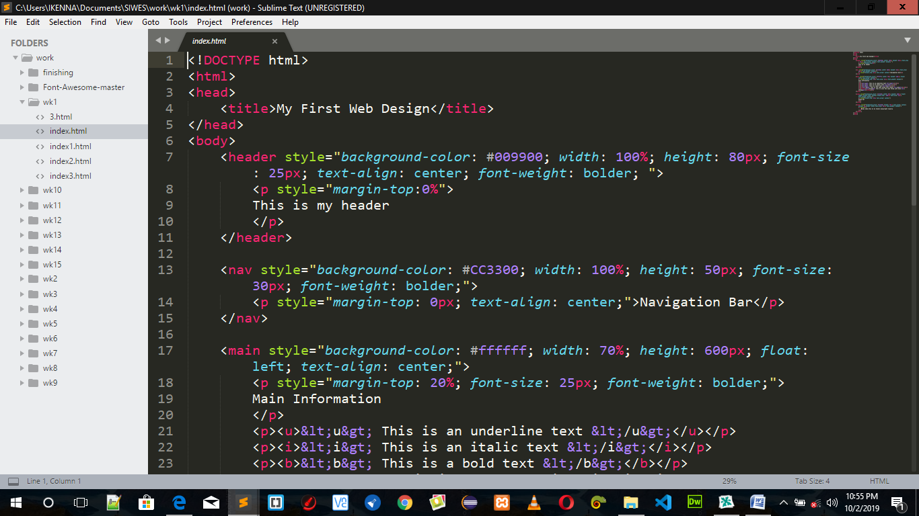
Inline Style: It is used to apply a unique style to a single HTML element. An inline CSS uses the style attribute of an HTML element.

Fig 3.2 Inline style
Internal/Embedded Style: It is used if one single page has a unique style. Internal styles are defined within the <style> element, inside the <head> section of an HTML page. It is also called embedded CSS.

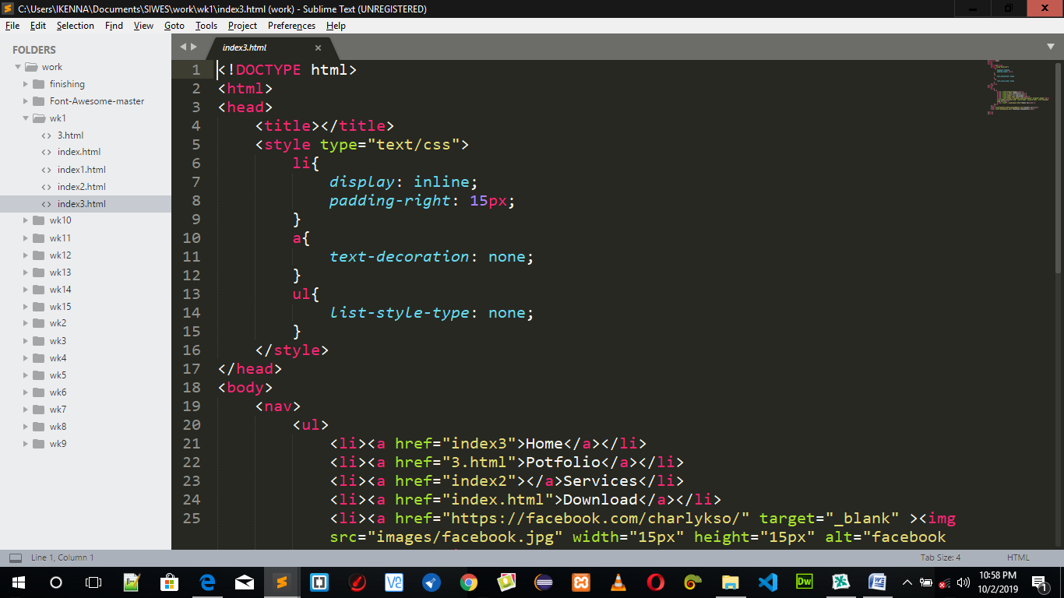
Internal/Embedded style
External Style: With an external style sheet, you can change the look of an entire website by changing just one file. Each page must include a reference to the external style sheet file inside the <link> element. The <link> element goes inside the <head> section. Also when using external CSS it is preferable to keep the separate from your HTML. Placing CSS in a separate file allows the web designer to completely differentiate between content (HTML) and design (CSS). External CSS is a file that contains only CSS code and is saved with a “.css” file extension. This CSS is then referenced in your HTML using the <link> instead of <style> as earlier stated.

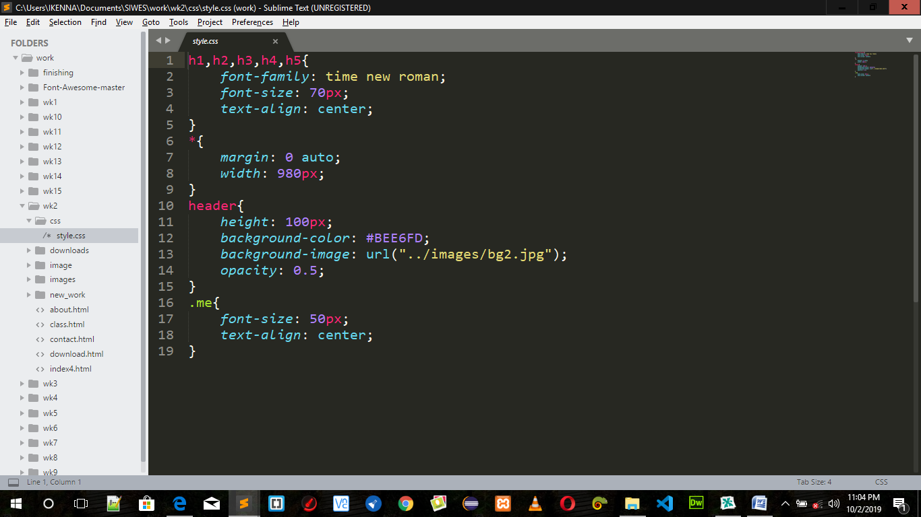

Fig 3.4 External Style

CSS3 Modules
CSS3 has been split into "modules". It contains the "old CSS specification" (which has been split into smaller pieces). In addition, new modules are added.
Some of the most important CSS3 modules are:
- Selectors
- Box Model
- Backgrounds and Borders
- Image Values and Replaced Content
- Text Effects
- 3D Transformations
- Animations
- Multiple Column Layout
- User Interface
CSS supports color names, hexadecimal and RGB colors. In addition, CSS3 also introduces: RGBA colors, HSL colors, HSLA colors, opacity. Flexible boxes, or flex box, are a new layout mode in CSS3. Use of flex box ensures that elements behave predictably when the page layout must accommodate different screen sizes and different display devices. For many applications, the flexible box model provides an improvement over the block model in that it does not use floats, nor do the flex container's margins collapse with the margins of its contents. Media queries in CSS3 extend the CSS2 media type idea: Instead of looking for a type of device, they look at the capability of the device.
3.1.1.3 Bootstrap and Its Features
(web-development, n.d.)Bootstrap is the most popular HTML, CSS, and JavaScript framework for developing responsive, mobile-first web sites. It’s a free front-end framework for faster and easier web development, Bootstrap includes HTML and CSS based design templates for typography, forms, buttons, tables, navigation, modals, image carousels and many other, as well as optional JavaScript plug-ins. Bootstrap also gives you the ability to easily create responsive designs. Responsive web design is about creating web sites which automatically adjust themselves to look good on all devices, from small phones to large desktops, Bootstrap makes use of HTML class property.
Bootstrap provides a 12 column grid system. If you take a desktop screen of width 1024px, the total viewport is divided into 12 columns. The width of each column is 78px and the gutter width (gaps between the column content) is 30px (15px on each side of column). The width of columns and gutters varies based upon the screen size.
Bootstrap’s grid system is responsive (the grids adjusts or adapts based upon the screen or viewport size). For example, a single column grid designed for mobile screens can be transformed into a two column grid for tablets, desktops and as a three column grid in case of big screens like TV’s, by applying proper CSS classes.
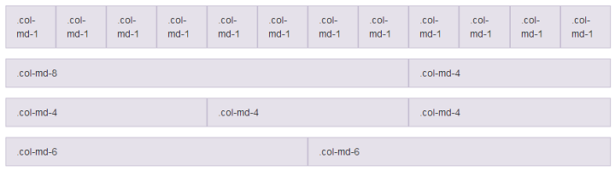
Fig 3.5 Bootstrap Grid System
PROJECT DONE
During the course of the training, I did mini projects with Html, Css, bootstrap to make the website.
Project 1
I successfully crafted an intuitive age calculator for my IT project, seamlessly blending HTML, CSS, and Bootstrap to create a visually appealing and user-friendly interface. This project not only showcases my technical skills but also demonstrates my ability to design practical and engaging web applications.

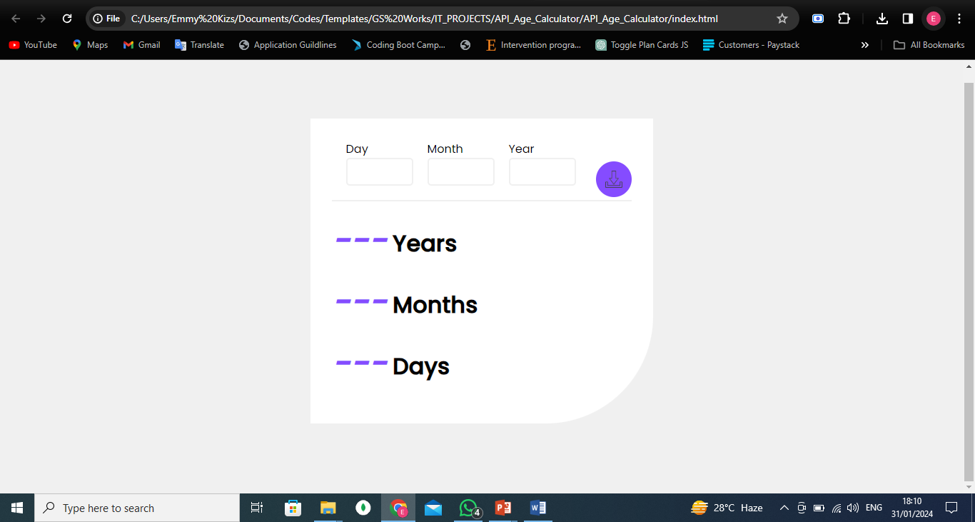
Fig 3.6 Screenshot of the interface 1
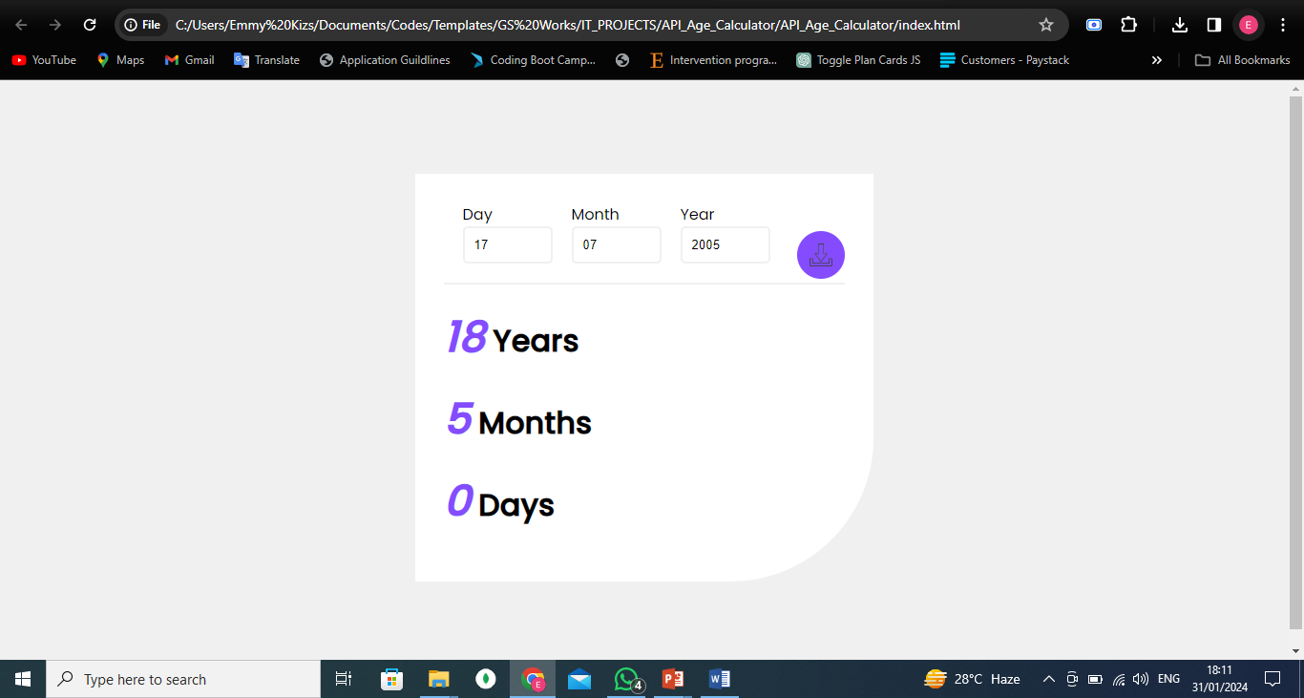
Fig 3.7 Screenshot of the Output
Project 2
In addition to the age calculator, I developed a comprehensive registration form using HTML, CSS, and Bootstrap, ensuring a seamless and responsive user experience. This project reflects my proficiency in creating functional web forms with a focus on user-friendly design and data integrity.
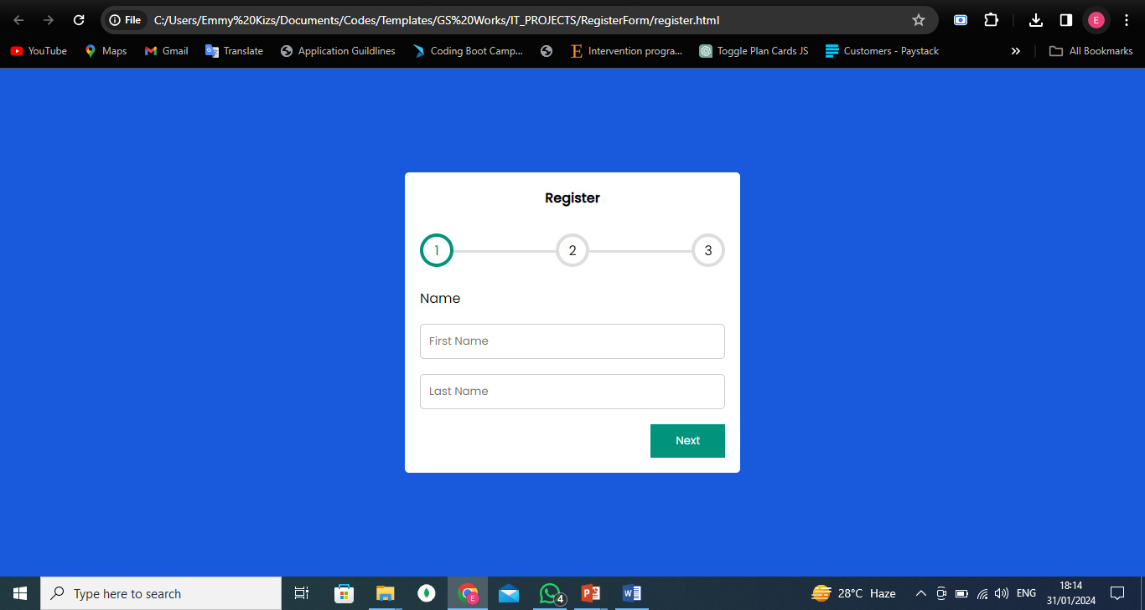
Fig. 3.8 Screenshot of Registration form 1
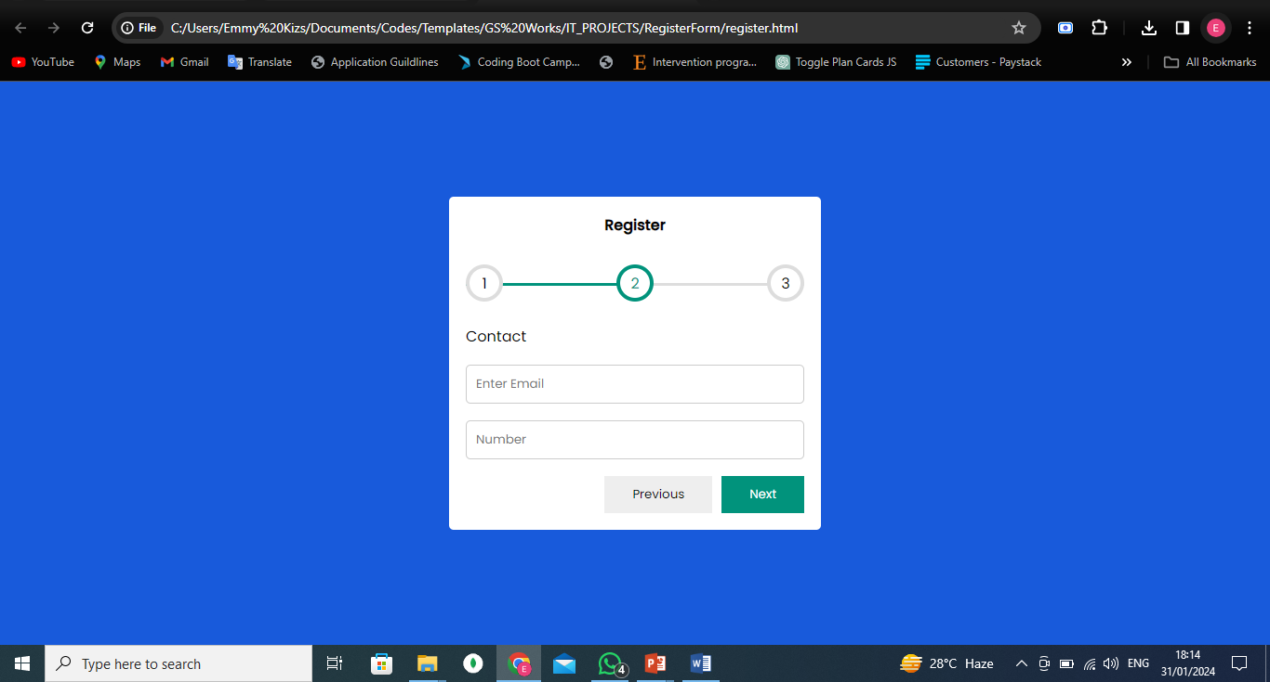
Fig 3.9 Screenshot of Registration form 2

3.2 Social and Functional Skills Acquired
As someone who worked in this tech company, I can attest to the many social and functional skills that I acquired in such an environment. One of the most important skills that I learned was effective communication. In the tech company, it is essential to be able to clearly communicate ideas, collaborate with team members, and provide feedback to one another.
Another critical skill that I developed was problem-solving. Working in a tech company often involves complex problem-solving, and I had to learn how to analyze data, identify issues, and develop solutions to problems.
Time management was also a skill that I learned while working in this tech company. With multiple projects and deadlines to manage, I was able to prioritize tasks and manage my time effectively to ensure that work was completed on time and to a high standard.
Teamwork and collaboration were also critical skills that I developed while working in this tech company. I learned how to work collaboratively, share ideas, and support my team members to achieve success.
Adaptability was another essential skill that I learned. In the fast-paced tech industry, companies must adapt to stay relevant, and employees must be willing to learn new skills to keep up with the changes.
Leadership skills were also important, and I had the opportunity to develop these skills as I progressed in my career. Delegation, motivation, and goal-setting were all essential components of effective leadership.
Finally, working in this tech company provided me with opportunities to learn and develop technical skills, such as coding, data analysis, and software development.
Therefore, working in this tech company provided me with a diverse range of social and functional skills that are highly valued in today's job market. These skills have helped me to succeed in my career and have been invaluable in both my personal and professional life.
3.3 Personal Input to the Organization
As a member of an organization, I believe that every individual can make a valuable contribution to an organization, and I did so in the following ways:
- Sharing Ideas: One way that I provided personal input to the organization is by sharing my ideas. I believe that everyone has unique perspectives and experiences that can bring value to the table. By sharing my ideas, I contribute to the organization's growth and success.
- Providing Feedback: Another way that I provided personal input is by providing feedback. As a member of the organization, I have a unique perspective on how things are working, and I provide constructive feedback that help improve processes and outcomes.
- Taking Initiative: I believe that taking initiative is an important part of providing personal input. When I see an opportunity for improvement or a problem that needs to be solved, I take the initiative to address it. By taking ownership of my work and the organization's success, I make a valuable contribution.
- Collaborating with Others: Collaboration is key to success in any organization. By working with others, I leverage their strengths and expertise to achieve common goals. I believe that collaboration can lead to creative solutions and new ideas that can benefit the organization.
- Supporting Others: Finally, I believe that supporting others is an important way to provide personal input to an organization. By being a positive and supportive team member, I contributed to a positive work culture and help others succeed.
3.4 Challenges Encountered
Working in any organization can present its own unique set of challenges. In my experience, some of the challenges that I encountered while working in the organization include:
- Communication breakdowns: Misunderstandings occur when there is a lack of effective communication, which lead to delays and errors in the completion of tasks.
- Conflicting priorities: Different individuals within the organization have conflicting priorities or goals, which make it challenging to work together towards a common objective.
- Time management: The Organization often have multiple projects or tasks that need to be completed within a specific timeframe. Managing one's time effectively is challenging, especially when there are competing priorities.
- Resistance to change: The Organizations is resistant to change and implementing new ideas, which can be frustrating for us who see the potential benefits of the changes.
- Team dynamics: Working in teams is challenging if there are personality clashes or disagreements, which impact the effectiveness and productivity of the team.
- Workload and stress: The workload and stress of working in this organization is high, especially during peak periods or when working on critical projects. This impact work-life balance and individual well-being.
Despite these challenges, I have learned that it is important to remain positive and proactive in finding solutions. Building strong relationships with colleagues, setting clear priorities and goals, and being open to feedback can help overcome many of these challenges. Additionally, seeking support from colleagues, mentors, or professional development resources can help individuals develop the skills and strategies needed to overcome challenges and succeed in their roles.
CHAPTER FOUR
SUMMARY, CONCLUSIONS AND RECOMMENDATIONS
4.1 Summary of Attachment Activities
My twenty weeks Industrial Training at Goodisoft Technologies was a great experience and a success. Through the period of the industrial training, I acquired the practical knowledge on my chosen career which enabled me to blend the theoretical knowledge acquired from school with very day practice during this period. Through this training I was able to gain new insights and more comprehensive understanding about the real industry working condition and practice. All of this valuable experience and knowledge I have gained most especially on web application were not only acquired through the direct involvement in task given but also through other aspect of the training such as work observation and online training.
4.2 Conclusions
My experience during the period of the training, I am very sure that the industrial training program has achieved its entire primary objectives. It is also the best way to prepare students to face the real working life. As a result of the program, I am now more confident to build my future career in software development.
4.3 Recommendations
- Students should start developing their Skills right from their day 1 in school. This will make Employers to place much value on them even as an IT Student.
- The School authorities should kindly set-up Social Clubs that has the potential of helping students in respect to their Career.
- The top Experts from various Industries (Telecommunications, Information Technology, Electronics etc.) should try to volunteer to come and enlighten Students on the current trends in their various Industries. This will help the Students to get prepared for the challenges they will face after graduation

References
https://siwesbeginner.com/siwes-introduction/
https://www.nou.edu.ng/directorates/students-industrial-work-experience-scheme-siwes
https://nigerianfinder.com/history-of-siwes/#:~:text=SIWES%20was%20established%20by%20ITF,institution%20graduates%20by%20Nigerian%20Industries.&text=This%20was%20a%20huge%20problem%20for%20thousands%20of%20Nigerians%20until%201973.
https://siwesbeginner.com/siwes-introduction/
Retrieved from https://www.studiobinder.com
Retrieved from https://en.wikipedia.org/
Alabi. (2019). Assessment of SIWES Relevance to Business Education Programme Objectives.
Bureau of Labor Statistics, U.S. Department of Labor. (2013, January 17). Information Security Analysts, Web Developers, and Computer Network Architects. Occupational Outlook Handbook, pp. 2012-13.
Campbell, J. (2017). Web Design. Introductory. Cengage Learning., 27.
(2015/2016). Student industrial work experienced scheme handbook.
web-development. (n.d.). Retrieved from https://www.techopedia.com/definition/

APPENDIX

<html>
<head>
<title>Trudy's Hair Place.</title>
<link rel="stylesheet" href="saloon.css">
<link rel="stylesheet"
href="https://stackpath.bootstrapcdn.com/font-awesome/4.7.0/css/font-awesome.min.css">
<meta name="viewport" content="width=device-width, initial-scale=1">
<link href="https://fonts.googleapis.com/css?
family=kaushan+Script|Poppins&display=swap" rel="stylesheet">
<script src="https://cdn.jsdelivr.net/gh/cferdinandi/smooth-scroll/dist/smooth-scroll.polyfills.min.js"></script>
</head>
<body>
<a href="http://127.0.0.1:5500/saloon.html">Hair Studio</a>
<section id="banner">
<img src="logo.jpg.jpg" class="logo">
<div class="banner-text">
<h1>Hair Studio</h1>
<p>Style Your Hair Is Style Your Life</p>
<div class="banner-btn">
<a href="#"><span></span>Find Out</a>
<a href="#"><span></span>Read More</a>
</div>
</div>
</section>
<div id="sideNav">
<nav>
<ul>
<li><a href="#banner">HOME</a></li>
<li><a href="#feature">FEATURES</a></li>
<li><a href="#service">SERVICES</a></li>
<li><a href="#testimonial">TESTIMONIALS</a></li>
<li><a href="#footer">MEET US</a></li>
</ul>
</nav>
</div>
<div id="manuBtn">
<img src="download.png" id="menu">
</div>
<!--Features-->
<section id="feature">
<div class="title-text">
<p>FEATURES</p>
<h1>Why Choose Us.</h1>
</div>
<div class="feature-box">
<div class="features">
<h1>Experienced Staff</h1>
<div class="features-desc">
<div class="feature-icon">
<i class="fa fa-shield"></i>
</div>
<div class="feature-text">
<p>Donec eget ultricies sapi. Sed porttitor, mauris ater lob facilsis, elit sapie eleifend ligula</p>
</div>
</div>
<h1>Pre Booking Online</h1>
<div class="features-desc">
<div class="feature-icon">
<i class="fa fa-check-square"></i>
</div>
<div class="feature-text">
</div>
</div>
<div class="features-img">
<img src="a7017f7794c4f8c454b574c292cdc2f0.jpg">
</div>
</div>
</section>
</body>
</html>

